22.28: All the 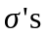 are absolute values.
(a) at 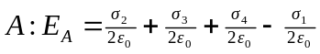
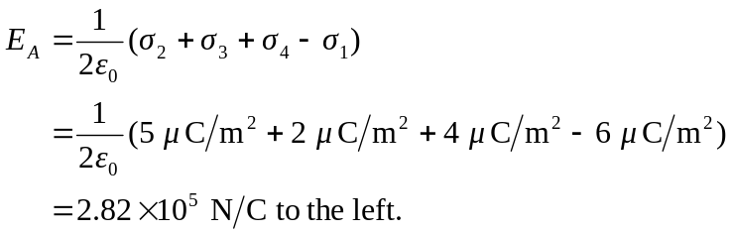
(b)
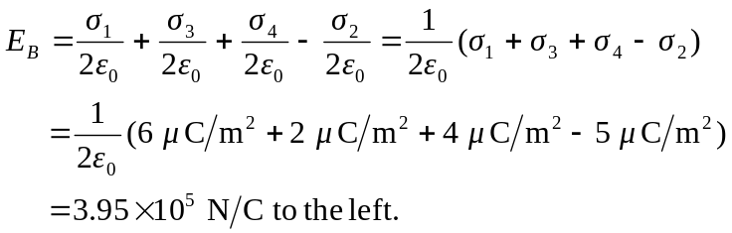
(c)
